
BIO101- Epidemiology Project: Fitting of SIR Model
Region: District of Columbia
Dated: - June 25(Thursday), 2020
Indian Institute of Technology, Goa

Mayank Shreshtha
1906322

Swadesh Choudhary
1906338


PREFACE
As we all know that science isn’t only limited till the course books, science is somewhat we can say, study for practical applications and innovations, to make livelihood for mankind more convenient, which even matters a lot for engineering. And talking about biology it always becomes a lot easier to analyse things more practically and observing them in person. So for the glimpse of the such aspect of biology, we were supposed to frame a SIR model for the current pandemic for the region of “District of Columbia, USA”.
I would like to thank Mr. Sreenath Balakrishnan being so supportive and giving us an opportunity to understand the mathematical aspect of biology to the certain depth. This project also encouraged me to do a lot of research which helped me to enhance my knowledge.

Table of Contents
Sl. No. | Content | Pg. No.
1 | Abstract | 4
2 | Introduction | 4
3 | Data Modelling | 5
4 | Ways to Control the Spread | 6
5 | Obtained Results | 6
6 | Sources | 7

- ABSTRACT:
This report is all about the current outbreak of corona virus disease, which the whole world is dealing with. It started in December 2019, and was first reported in the Wuhan city of China, started to spread like wild fire at it earliest. And was declared a pandemic on 11th of March, 2020 by the World Health Organization. Till the date around 9.44M people are affected from the virus which includes 483K deaths worldwide. Even our country is dealing with 473K confirmed cases which includes 14,894 deaths. Currently, many countries are under lockdown as a preventive measure from this outbreak.

- INTRODUCTION:
An SIR model is an epidemiological model that computes the theoretical number of people infected with a contagious illness in a closed population over time. The name of this class of models derives from the fact that they involve coupled equations relating the number of susceptible people , number of people infected , and number of people who have recovered .
This report deals with the covid scenario in the District of Columbia (Washington, D.C.). Washington, D.C. has a total population of 7.06lakhs among which there are 10,128 confirmed cases, 1,182 recovered and 541 death cases till now.
Current scenario of Washington, D.C.;
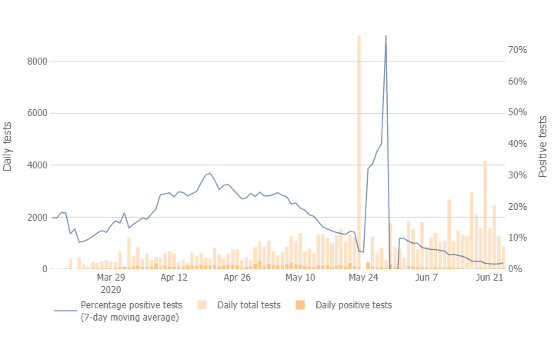
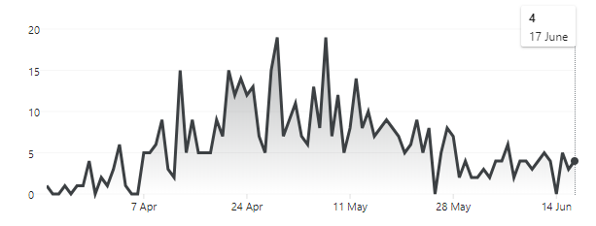
Death cases in Washington, D.C.

- DATA MODELLING:
S(t) – Number of susceptible individuals at time ‘t’.
I(t) – Number of infected individuals at time ‘t’.
R(t) – Number of recovered + died individuals at time ‘t’.
N – Total population of Washington, D.C.

In SIR models, the number of susceptible is supposed to decrease only, number of infectious once rises and then decreases at sometime and the number of recovered individuals is supposed to increase only.
The model consists of a system of three coupled nonlinear ordinary differential equations,

- $\frac{dS}{dt}$ = -r*S*I
- $\frac{dI}{dt}$ = r*S*I – a*I
- $\frac{dR}{dt}$ = a*I
Where, r = rate of transmissibility and a = rate of recovery

$\frac{dS }{dt}$ + $\frac{dI}{dt}$ + $\frac{dR}{dt}$ = 0

S(t) + I(t) + R(t) = N
Initially, let’s say I₀ people gets infected at time = t
So, S = S₀ at time ‘t’ i.e. S₀ + I₀ = N
Cases that can arise:
- S decreases monotonically and R increases monotonically
- I can decrease monotonically; in such cases there is no epidemic
- At first, I increase and then decreases; such cases are treated as epidemic
When S(t) < $\frac{a}{r}$ then there’s no epidemic [ $\frac{a}{r}$ = ρ; relative removal rate]

- WAYS TO CONTROL THE SPREAD:
- By giving vaccine to a specific number of people so that ρ becomes greater than the susceptible individuals.
- By the concept of ‘Herd Immunity’ which refers to willingly infecting a good number of susceptible people.
- Reducing the transmissibility rate through preventive measures.
- Increasing the recovery rate through proper treatment.

- OBTAINED RESULTS:
To fit the data, following procedures have been applied;
- Guessing the parameters of the differential equation.
- Simulating the equations using these parameters.
- Calculate the error of the simulated result with the data. Which is taken as the sum of squares of the difference between the simulation and the data.
- Changing the parameters such that the error is reduced.
Basically, can say that we worked on a dummy data to match it up to the mark.
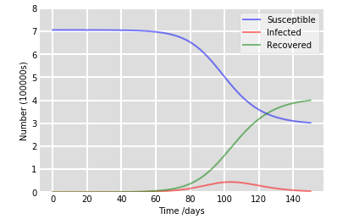
Obtained value for rate of transmissibility (r) = 0.3 and that of the rate of recovery (a) = 0.2
Obtained curve gives a rough idea about the decreasing rate of susceptible individuals in the time, increasing rate if infectious and the increasing rate of the recovered or died people with time. Looking at it, we can say that the peak of infectious will be around 102nd - 105th day. However, the curve can be changed by taking special measures.

- SOURCES:
- https://mathworld.wolfram.com/
- https://news.google.com/
- https://covid19.healthdata.org/
- https://opendata.dc.gov/
- https://www.nbcwashington.com/

